***Group no. 1***

Organization Name:

Integrated Business Solution

Group Members:

Affan Khan 19P-0045

Istafa Malik 19P-0033

Faiq Aslam 19P-0082

Rana Rehan 19P-0077

*What is an organization?*

Organization is basically an organized group of people with a particular purpose, such as a business or government department.

*Purpose of Organization:*

Purpose of an organization is to make profit and to take their employees with themselves. An organization is led by a manager (can be owner or not).

He/she has number of employees working under him/her. There are different people serving the organization on different positions. The manager is at the top level.

Any organization is lead through planning (In which they define their goals, plan to achieve them, and work on more developing plans. Organizing is also the major part of successful organization

(Structuring of the work is done to achieve the goals).Leader also describes a successful organization (Working with the people and leading them and taking them with u).

*How to run an organization:*

The success of an organization depends on the effiency and the effectiveness of the manager, employs and employees. No organization can be effective without skilled employees. Hence, you need to select employees with the right experience to perform various functions. Keep a constant watch on your competition. Competitors often counter your business strategies, which can greatly impact your sales and profits.

THE goal of our organization is;

*“BE THE LEADER AND A TRENDSETTER ".*

*Introduction:*

**IBS is an organization which was incorporated in 2000 and works under PBD (Pakistan business development). IBS is basically an (IT) business related to computer builders and scanners. It is one of the toppest known IT businesses’ in Islamabad. However it operates in different parts of the country (Pakistan).Because of the quality work people refer the IBS.

The company provides services in camera operating, back hand programs used at super stores, Computer repairing and computer programming.

A manager is a person who is responsible for a part of a company, i.e., they ‘**manage**‘ the company. Managers may be in charge of a department

and the people who work in it. In some cases, the manager is in charge of the whole business. A manager is a person who exercises managerial functions primarily. They should have the power to hire, fire, discipline, do performance appraisals, and monitor attendance.

They should also have the power to approve overtime, and authorize vacations.

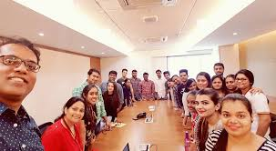

*Types of Managers:*

There are four type of managers;

* ***Front line manager***

AMMAR JANJUA

He is the front line manager, He makes sure that every employ and worker us working and is not on a holiday. He manages their living, their food and their pay as well. He has a great work to do as he also leads his team when the team visits any place for the installation of the software and the system.

* ***Middle Manager***

AHMED MUNIR

He is the middle manager and has complete authority to pass orders when MUHAMMAD MUNIR (the front line manager as well as his father is not in work, or is abroad). He deals in the public sector and the final output and material is first shown to him. His basic role is to take new orders from the different companies and make sure that the work is done on time.

* ***Top Manager***

MUHAMMAD MUNIR

He is the front line manager, he deals with the all employees under him and has hold on the organization (He is also the owner), He has done a lot of social work as well from the extra bonuses and he is responsible for passing any of the output and material made by the IBS.

*ORGANISATIONAL BEHAVIOUR*

Organizational behavior is the study of both group and individual performance and activity within an organization.

This area of study examines human behavior in a work environment and determines its impact on job structure, performance, communication, motivation, leadership.

The organizational behavior at IBS is lenient, as relief of every type is given to the employees, so that they can feel easy to work at IBS, rather than taking the work as a burden. Every type of the relaxation is given to the employees as well as to

Customers which is the main reason of success, as without workers or customers any organization is nothing. Super discount offers are also announced monthly which is why the business is

Succeeding day by day.

*Organizational Culture:*

Organizational culture is defined as the underlying beliefs, assumptions, values and ways of interacting that contribute to the

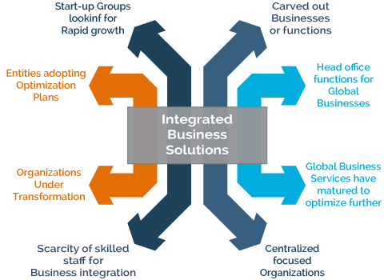 Unique social and psychological environment of an organization.

Organizational culture includes an organization’s expectations, experiences, philosophy, as well as the values that guide member behavior, and is expressed in member self-image, inner workings,

Interactions with the outside world, and future expectations. Culture is based on shared attitudes, beliefs,

Customs, and written and unwritten rules that have been developed over time and are considered valid.

The culture at IBS is very comfortable every worker is allowed to follow their culture. No restriction is there on hiring the employees from specific area

, people from all over the Pakistan come to IBS and work easily. IBS provides a literate and worth it platform to the fresh graduates and polishes them with the skills.

*STRONG CULTURE*

in an organization with a strong culture respects everyone's culture. Employees respect the people and their cultures as well. Employees put their differences aside and

Work together for the development of the organization. The employees are trained in a way that they strongly believe in the cultures and respect different kind of cultures.

*WEAK CULTURE*

A culture is weak when its beliefs, behavioral rules, traditions, and rituals are not apparent to its members or there is incongruence between stated values and behavior. This can happen for a variety of reasons. With no knowledge of what the organization stands for or how things are actually done (rather than how policy indicates things should be done),

Weak cultures work against the success of an organization. There is a religion, gender and color discrimination in a weak culture and IBS strictly forbids these. The employees are fined when they do so that this is never practiced again.

*STAKEHOLDERS*

Stakeholders can affect or be affected by the organization's actions, objectives and policies. They can have a direct or indirect impact on the organization. A person or group of people who own a share in a business.

. Employees play an important role in contributing to the long-term success and performance of the organization

.The customer service of IBS is one of the best as they understand the problem of the customers and try to resolve them as soon as possible.

They know that customer have a great impact on their organization.

*SHAREHOLDERS*

A shareholder can be a person, company, or organization that holds stock(s) in a given company.

A shareholder must own a minimum of one share in a company’s stock or mutual fund to make them a partial owner

AHMED AZAD (CDA CHAIRMAN)

MUNIR HASSAN (owner of famous superstores in Islamabad)

*COMPETITORS*

Any person or entity which is a rival against another. In business, a company in the same industry or a similar industry which offers a similar product or service.

The presence of one or more competitors can reduce the prices of goods and services as the companies attempt to gain a larger market share.

SAP, MICROSOFT DYNAMICS, SAGE are the three of the four top software businesses in the twin cities and across.

*Departments in IBS*

There are different departments in IBS which includes

* PUBLIC/CUSTOMER DEALING
* PUBLICITY DEPARTMENT
* ACCOMODATION